Design and Implementation of a Keypad-Operated 4-Bit Arithmetic Logic Unit (ALU) in Proteus
Md.Mehedi Hasan Khan Apurbo, Md.Fathin Hasnath Amil, Md.Rafiul Islam Riad
Department of Electrical, Electronic and Communication Engineering (EECE)
Military Institute of Science and Technology (MIST), Dhaka, Bangladesh mehedihasanapurbo7979@gmail.com, md.fathinhasnathamil@gmail.com, rafiulriad44@gmail.com

Abstract—This paper presents the design, Proteus simulation, and planned hardware realization of a 4-bit Arithmetic Logic Unit (ALU) that performs addition, subtraction, and multiplication of two operator-entered decimal operands. Each operand is entered through a 4×4 matrix keypad and converted to a 4-bit binary code by an MM74C922 keyboard-encoder IC. The operands are routed into two parallel arithmetic sections built from 74-series combinational logic: an addition/subtraction section using cascaded 7483 4-bit adders with 74LS86 XOR gates for two’s-complement generation, and a multiplication section using a 7408 AND-gate array to form partial products, summed by additional 7483 adders. 74157 multiplexers route data within each section, and two ATmega328P microcontrollers decode the binary results and drive seven-segment displays (two digits for addition/subtraction, three digits for multiplication). The complete circuit was captured and functionally verified in the Proteus Design Suite.
Index Terms—Arithmetic Logic Unit, combinational logic, binary adder, two’s complement, partial products, keyboard encoder, Proteus simulation, microcontroller display decoding.

- Introduction
The Arithmetic Logic Unit (ALU) is the computational core of every digital processor, responsible for executing arithmetic operations on binary operands. Studying how an ALU can be assembled from elementary logic gates, adder ICs, and supporting control/display circuitry provides practical insight into digital system design and the hardware realization of arithmetic functions. This project implements a simplified 4-bit ALU that accepts two decimal operands through calculator-style keypads, converts each keypress into a binary code, and performs addition, subtraction, or multiplication using discrete 74-series logic combined with microcontroller-assisted result decoding and seven-segment display output. The problem addressed in this project is to design and simulate a 4-bit digital ALU capable of performing addition, subtraction, and multiplication of two user-supplied operands, where the operands are entered through keypad inputs, processed using digital logic circuits, and the resulting value is displayed on seven-segment displays. Specifically, the project aims to (i) convert keypad-entered digits into binary signals; (ii) implement the logic required for binary addition and subtraction using a shared adder/XOR arrangement; (iii) generate and combine partial products for multiplication using AND-gate logic and adder ICs; (iv) route data correctly between the input, arithmetic, and output
sections; (v) produce accurate arithmetic outputs; (vi) convert binary results into a multi-digit seven-segment display format; and (vii) verify the complete operation through Proteus simulation. The scope of this project is limited to a 4-bit ALU performing three arithmetic operations – addition, subtraction, and multiplication – verified through Proteus simulation. Logical operations (AND, OR, XOR, NOT) as user-selectable ALU functions, flag registers beyond the adder carry, and hardware bench verification are outside the current scope; hardware realization is planned future work (Section IX).
- Objectives and Design Specifications
- General Objective
To design and simulate a digital ALU capable of performing addition, subtraction, and multiplication using combinational digital logic circuits driven by a keypad interface, verified through the Proteus simulation environment.
- Specific Objectives
  - Design a keypad-based input interface converting each keypress into a 4-bit binary code.
  - Implement combinational logic for addition, subtraction (two’s-complement), and multiplication (partial products).
  - Integrate the arithmetic sections with multiplexer-based data routing.
  - Decode and display results using microcontroller-driven seven-segment displays.
  - Verify functionality for representative operand combinations in Proteus.
TABLE I: ALU Design Specifications

Parameter Specification

Operand width 4 bits per operand (keypad digit) Operations Addition, Subtraction, Multiplication Input method 4×4 keypad + MM74C922 encoder Result display 2-digit (add/sub); 3-digit (mult.)
Logic family 7408, 7483, 74LS86, 74157,
ATmega328P
Supply 5 V DC

- Theoretical Background
The ALU performs addition, subtraction, and multiplication of two 4-bit binary operands entered through a keypad. Only

the logic concepts directly used in the implemented circuit are summarized below.

- Binary Addition
Addition is performed by 7483 4-bit binary adder ICs. For each bit position:
S_{i} = A_{i} ⊕ B_{i} ⊕ C_{i} (1)
C_{i+1} = A_{i}B_{i} + C_{i}(A_{i} ⊕ B_{i}) (2) where A_{i}, B_{i} are the operand bits, C_{i} is the carry-in, and C_{i+1}
the carry-out of bit position i.

- Binary Subtraction
Subtraction reuses the 7483 adder hardware. Operand B is conditionally complemented with 74LS86 XOR gates and the carry-in is set to 1:

A − B = A + B + 1 (3)
- Binary Multiplication
Partial products are generated with 7408 AND gates (A_{i} ·B_{j} for each bit pair) and summed using additional 7483 adders. Since the product of two 4-bit numbers may reach 8 bits (max. 225 for 15 × 15), the result is decoded to a 3-digit display.
- Input Encoding and Output Decoding
Each keypad is connected to an MM74C922 keyboard encoder, which debounces the keypress and outputs a 4-bit code with a data-available strobe, latched and shown on a single-digit seven-segment display. Each arithmetic section feeds its binary result to an ATmega328P microcontroller, which performs binary-to-decimal decoding and drives the corresponding seven-segment display group.

- System Architecture and Methodology
The system consists of two keypad-based input sections, two parallel arithmetic sections (addition/subtraction and multiplication), and two microcontroller-driven output sections.

- Flow Chart
Keypad A / Keypad B → MM74C922 Encoder (binary conversion + digit display) → Arithmetic Processing [Add/Sub Section | Multiplication Section] → 74157 Multiplexer Routing → ATmega328P Decoding → Multi-digit Seven-Segment Display.
The arithmetic stage consists of two parallel paths rather than one shared core: a path for A+B and A−B using shared adder/XOR hardware, and an independent path for A × B using an AND-gate partial-product array. Each path has its
own ATmega328P and display group.
- Circuit Design Procedure
  - Operand Entry – Each operand is entered by pressing digit keys on its dedicated 4×4 matrix keypad (Keypad A = 6, Keypad B = 5 in this run).
  - Keypad Encoding – Each keypress is captured by its MM74C922 keyboard-encoder IC, which debounces the input and converts it into a 4-bit binary code.
  - Operand Confirmation Display – The encoded value is immediately shown on a single-digit seven-segment display next to each keypad (visible here as ”6” and ”5”), letting the user verify the entry before processing.
  - Arithmetic Routing – The two 4-bit binary operands are fed in parallel into two independent processing paths: the addition/subtraction path and the multiplication path.
  - Addition/Subtraction Processing – The 7483 adders combine the operands, with the 74LS86 XOR gates conditionally complementing B and the 74157 multiplexer selecting the add or subtract mode; here the circuit computed 6 - 5, giving a result of 01.
  - Multiplication Processing - The array of the 7408 AND-gate generates the partial products of A and B, which are summed by additional 7483 adders; here it computed 6 × 5, giving a result of 030.
  - Result Decoding and Display – Each path’s binary result is passed to its own ATmega328P, which decodes it and drives the corresponding seven-segment display group (2-digit for add/sub, 3-digit for multiplication), completing the operation.
- Simulation Setup
The complete circuit was captured and simulated in Proteus Design Suite. Matrix keypads with MM74C922 encoders provided numerical input; 7408/7483/74LS86/74157 ICs performed arithmetic processing and routing; ATmega328P microcontrollers performed decoding and seven-segment display drive.
- Design and Methodology
- 4-Bit Input Section
Each operand is entered via a 4×4 matrix keypad wired to an MM74C922 keyboard-encoder IC (U14 for operand A, U15 for operand B). The encoder outputs a 4-bit code on Y1–Y4
with a Data-Available strobe, and also drives a single-digit seven-segment display so the entered digit is visible before the operation proceeds.
- Arithmetic Unit
The binary values from the input section are routed to two independent arithmetic paths: an addition/subtraction path and a multiplication path, each with its own multiplexer routing stage and ATmega328P-driven display.
- Addition Operation
Addition is carried out by 7483 4-bit binary adder ICs (U1, U2), cascaded so the carry-out of the lower adder feeds the carry-in of the next stage. Operand nibbles are applied directly to the adder A and B inputs.

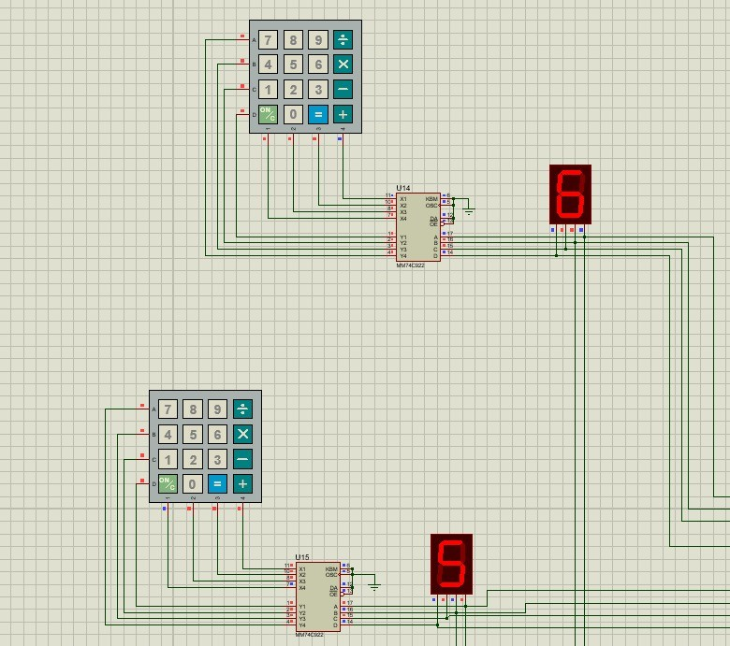
Fig. 1: Keypad input section: two 4×4 matrix keypads, each connected to an MM74C922 keyboard-encoder IC (U14, U15) driving a single-digit confirmation display.

- Subtraction Operation
Subtraction reuses the 7483 adder hardware. A bank of 74LS86 XOR gates (U4:A–D) conditionally complements each bit of B using a mode-select line, and the adder carry-in is set high for subtraction, so the adder computes A + B + 1.
- Multiplication Operation
Multiplication uses 7408 quad AND-gate ICs (U7–U10) to generate partial products (each bit of A AND-ed with each bit of B), summed by further 7483 adders (U3, U5, U6). Since the product may reach 8 bits, the result is decoded to a 3-digit display.
- Control / Selection Logic
74157 quad 2-to-1 multiplexer ICs route data within each section. In the addition/subtraction section, a 74157 (U11) selects the direct or complemented form of B ahead of the adder. In the multiplication section, two 74157 ICs (U13, U24) route partial-sum outputs to the ATmega328P.
- Output and Display Section
Each arithmetic path terminates in its own ATmega328P (U12 for add/sub, U16 for multiplication), which reads the binary result and drives the corresponding seven-segment display group – two digits for addition/subtraction and three digits for multiplication, avoiding a large discrete BCD-decoder network.
- Proteus Simulation and Implementation
- Simulation
The complete circuit, combining the keypad input section, the addition/subtraction section, and the multiplication section, is shown in Fig. 5. The two keypad/encoder input blocks are on the left, the multiplication block occupies the
upper-right region, and the addition/subtraction block occupies the lower-right region.
All seven-segment displays initialize to zero prior to a keypress, consistent with Fig. 5. [Insert a brief description of specific operand values entered and resulting displayed outputs once a simulation run has been logged.]
- Hardware Implementation
- Simulation Results
Table II summarizes the representative operand combinations to be tested for each operation. Specific values are left as placeholders, to be completed once the corresponding Proteus runs are logged.
TABLE II: Representative Test Vectors and Results

A B Operation Expected Simulated

[5] [6] Addition [11] [11]
[5] [6] Subtraction [01] [01]
[5] [6] Multiplication [30] [30]

- Discussion
The Proteus simulation confirms that the keypad-driven input stage correctly encodes user-entered digits and that the two arithmetic sections are structurally wired to compute addition, subtraction, and multiplication using shared 7483 adder hardware, 74LS86-based two’s-complement generation, and a 7408 AND-gate partial-product array. Reusing the adder hardware for addition and subtraction avoids a separate subtractor block.
- Practical Trade-offs
Ripple-through 7483 adders simplify the design at the cost of propagation delay that grows with the number of cascaded stages, particularly in the multiplication path. Offloading binary-to-decimal decoding to an ATmega328P reduces gate count and wiring at the cost of a firmware dependency for correct display behavior.
- Design Considerations
Because the two arithmetic sections use independent adder chains, multiplexers, and microcontrollers rather than a single shared datapath, the design resembles two purpose-built arithmetic circuits operating in parallel rather than a classical ALU with a shared select-line-controlled output.
- Limitations and Future Work
- Only addition, subtraction, and multiplication are implemented; AND/OR/XOR/NOT are not user-selectable ALU functions in the current design.
- Hardware (breadboard/bench) verification has not yet been carried out.
- The two arithmetic sections operate as separate parallel paths rather than a unified datapath.
- Division is not implemented.
- Future work: extend operand width, unify the operation-select scheme, and add logical operations.

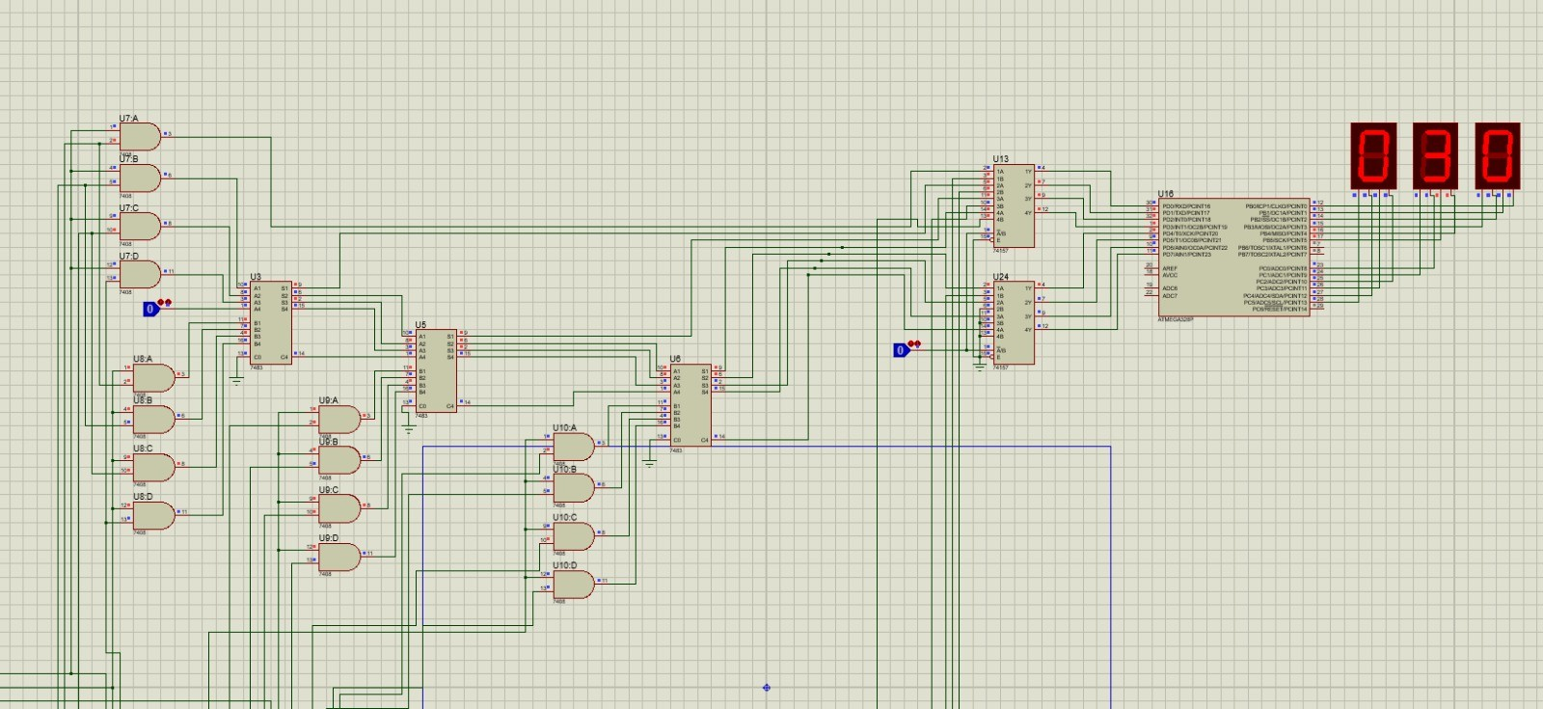
Fig. 2: Multiplication section: 7408 AND-gate partial-product array (U7–U10), 7483 summing adders (U3, U5, U6), 74157 routing multiplexers (U13, U24), and ATmega328P (U16) driving a 3-digit seven-segment display.
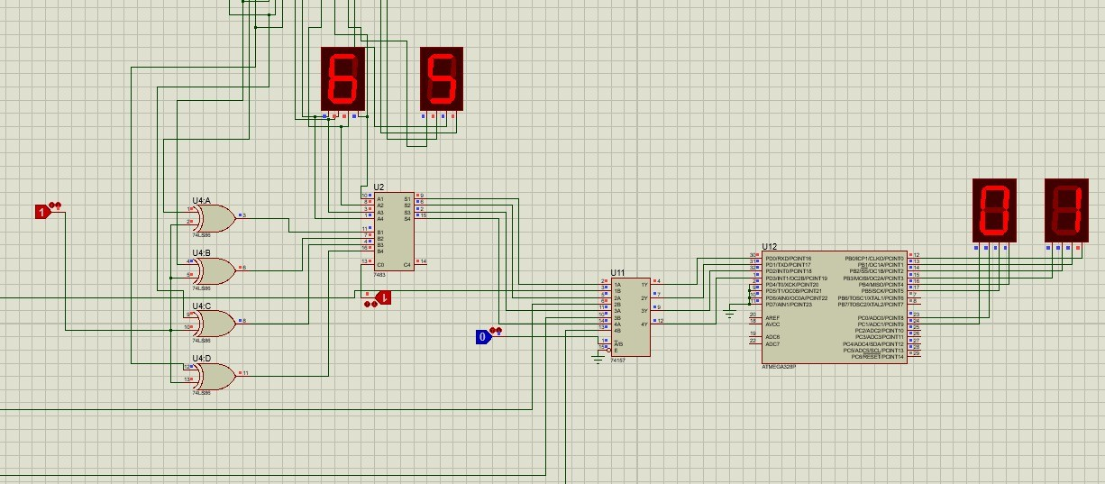
Fig. 3: Addition/subtraction section: cascaded 7483 adders (U1, U2), 74LS86 XOR gates for two’s-complement generation (U4), a 74157 routing multiplexer (U11), and ATmega328P (U12) driving a 2-digit seven-segment display.

- Conclusion
A 4-bit ALU supporting addition, subtraction, and multiplication was designed and simulated using a keypad-based input interface, 74-series combinational logic (7408, 7483, 74LS86, 74157), MM74C922 keyboard
encoders, and ATmega328P microcontrollers for result decoding and display. The Proteus simulation confirms correct structural implementation of the input, arithmetic, and output stages. Hardware verification remains as planned future work.

Acknowledgment
The authors thank the Department of EECE, MIST, for laboratory facilities and guidance during this project.
References
- M. M. Mano and M. D. Ciletti, Digital Design, 6th ed. Boston, MA, USA: Pearson, 2018.
- T. L. Floyd, Digital Fundamentals, 11th ed. Boston, MA, USA: Pearson, 2015.
- Texas Instruments, “SN7483 4-Bit Binary Adder with Fast Carry,” datasheet, [Online]. Available: https://www.ti.com
- Texas Instruments, “SN7408 Quadruple 2-Input AND Gates,” datasheet, [Online]. Available: https://www.ti.com
- Texas Instruments, “SN74LS86 Quadruple 2-Input XOR Gates,” datasheet, [Online]. Available: https://www.ti.com
- Texas Instruments, “SN74157 Quad 2-Line to 1-Line Data Selector/Multiplexer,” datasheet, [Online]. Available: https://www.ti.com
- Texas Instruments, “MM74C922 20-Key Keyboard Encoder,” datasheet, [Online]. Available: https://www.ti.com
- Microchip Technology, “ATmega328P 8-bit AVR Microcontroller,” datasheet, [Online]. Available: https://www.microchip.com
- Labcenter Electronics, “Proteus Design Suite Documentation,” [Online]. Available: https://www.labcenter.com

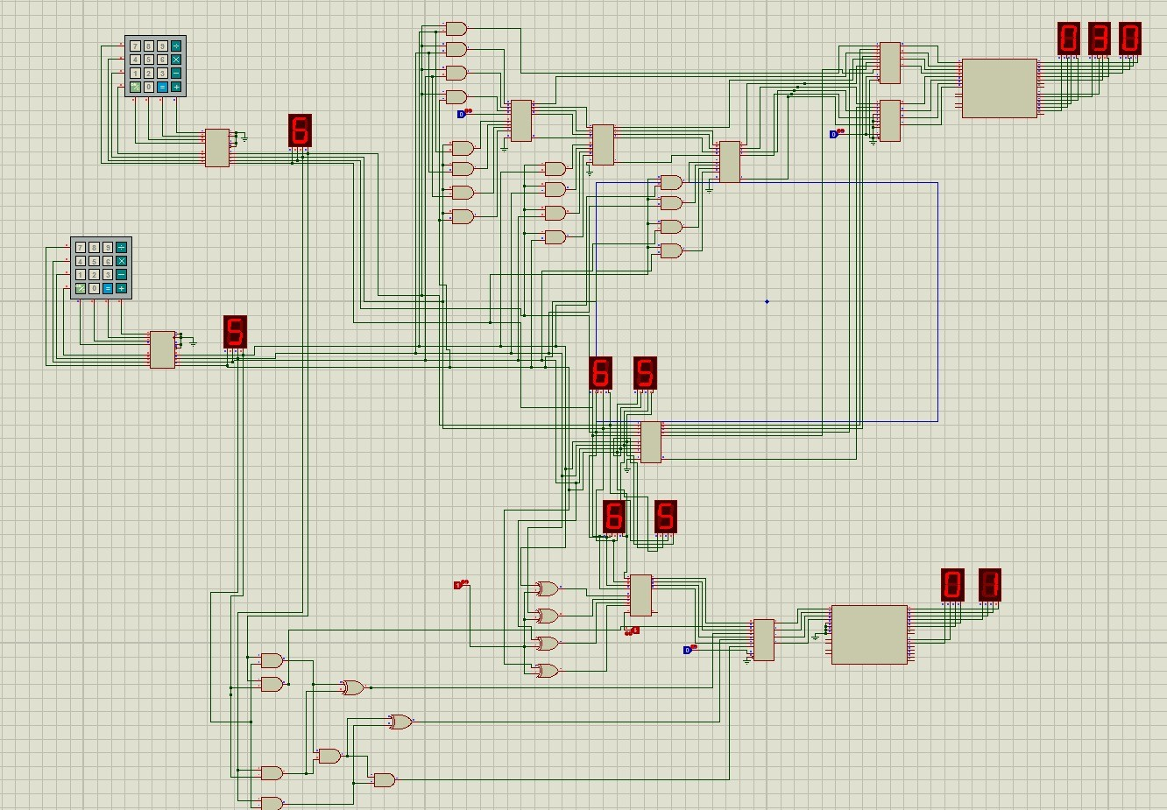
Fig. 4: Complete 4-bit ALU circuit, showing the keypad input blocks, the multiplication section, and the addition/subtraction section.

Appendix A
Materials and Team Contribution

TABLE III: Materials

Item | Qty
MM74C922 Keyboard Encoder | 2
4×4 Matrix Keypad | 2
7408 (Quad AND) | 4
7483 (4-Bit Adder) | 5
74LS86 (Quad XOR) | 1
74157 (Quad 2:1 MUX | 3
ATmega328P | 2
Single-digit 7-seg display | 2
Multi-digit 7-seg display group | 2
Breadboard & jumper wires | 1 set
5 V power supply | 1

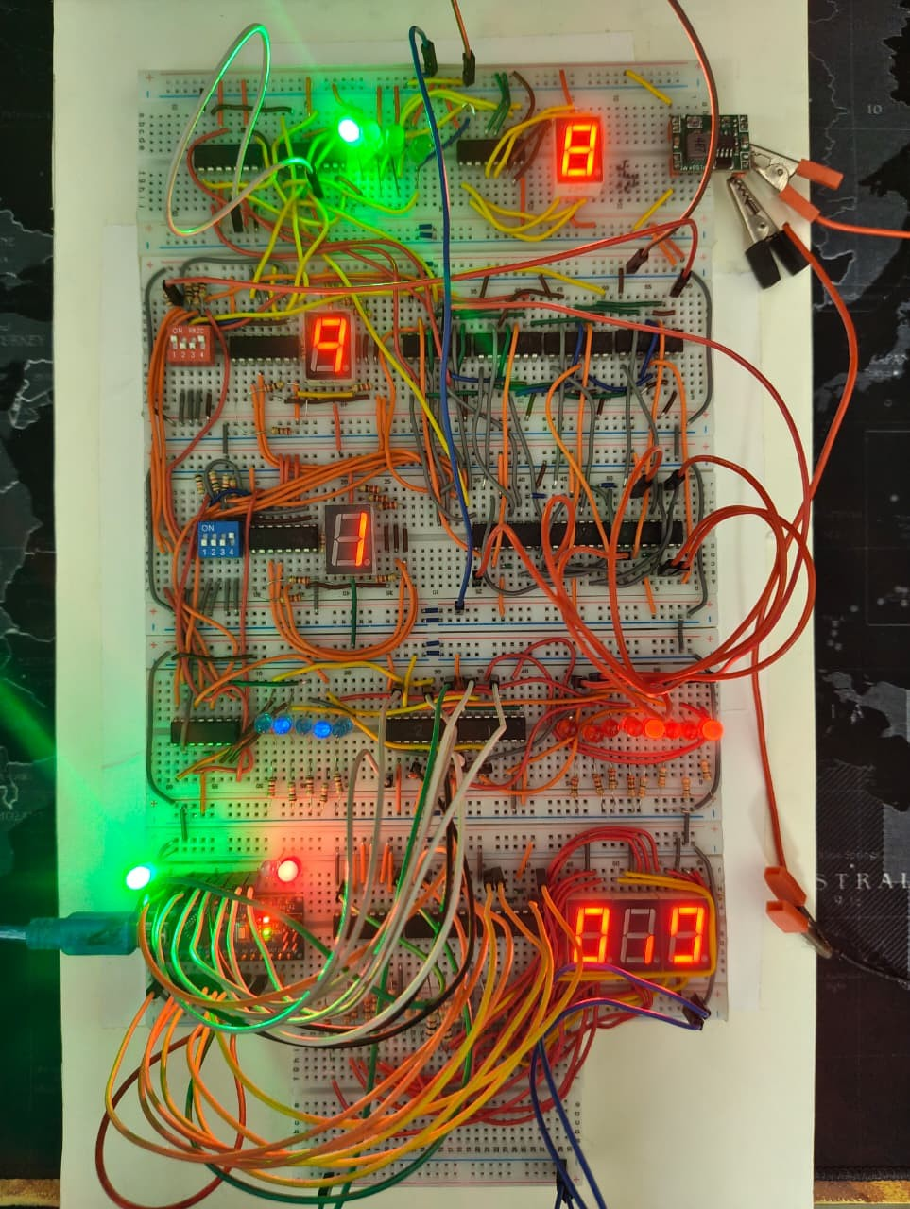
Fig. 5: Complete 4-bit ALU circuit, showing the keypad input blocks, the multiplication section, and the addition/subtraction section.

